**BattleShip**

**Design Document**

**Team 1**

**Skyler Thompson, Garrett Ellison, Alex Waitkus, Anish Gilani, and Taylor Cannon**

1. **Class Diagram Part I**

INCLUDED

1. **Class Diagram Part II**

As per our emails, we are using LucidChart for our class diagram so we cannot export our papyrus project

1. **Package Diagram**

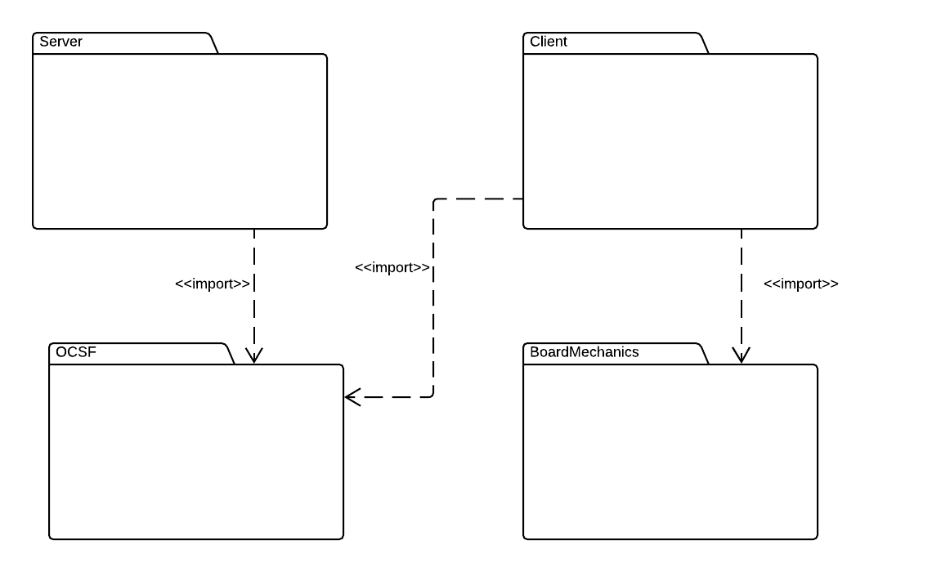

1. **Package (Sub-System) Input/Output**

**Package:** BoardMechanics

**Input:**

* Input from the Player in Attack.
* Input from the Player in Board.
* Input from the Player in ClientController
* Input from the Server in GameServer

**Output:**

* Game information from Board sent to Server

**Package:** Client

**Input:**

* Input from Player in ClientGUI
* Input from the Game in Board
* Game information from GameServer

**Output:**

* Network information sent from GameClient to OSCF
* Game information sent from GameClient to BoardMechanics
* Game information sent from GameClient to Server

**Package:** Server

**Input:**

* Input from the Admin in GameServer
* Input from the Admin in ServerGUI
* Input from the Player in GameClient
* Information about the board from GameClient

**Output:**

* Game information from Game sent to Client
* Game information from Game sent to BoardMechanics

**Package:** OCSF

**Input:**

* Input from server in ServerController
* Input from Player in GameClient

**Output:**

* Network information from ServerGUI sent to OSCF
* Network information from GameClient sent to OSCF

1. **Class Diagram Part III**

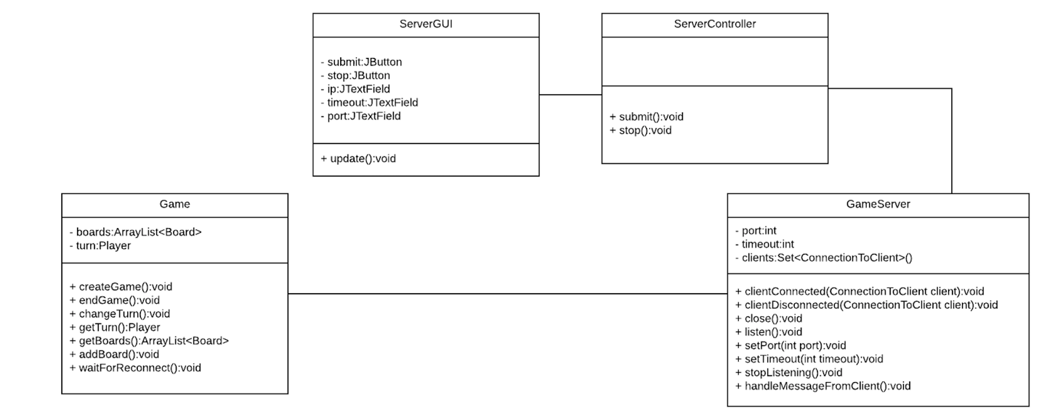

**Server Package**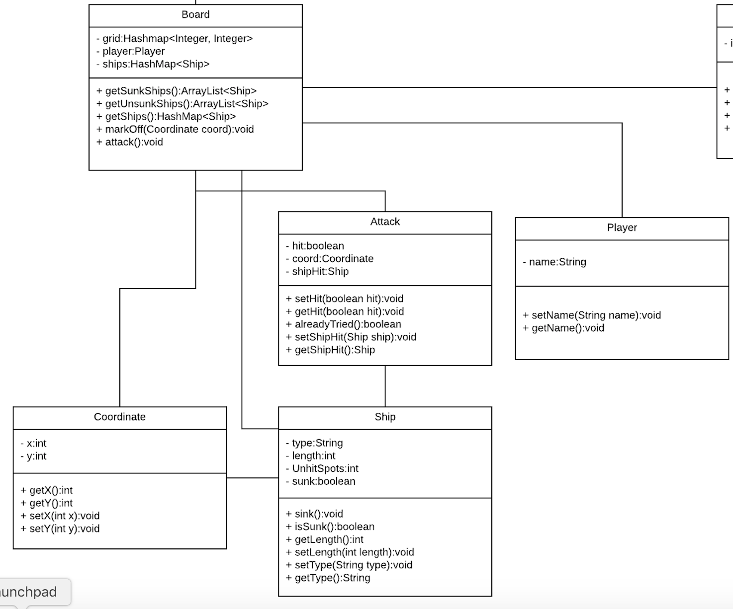

**Board Mechanics Package**

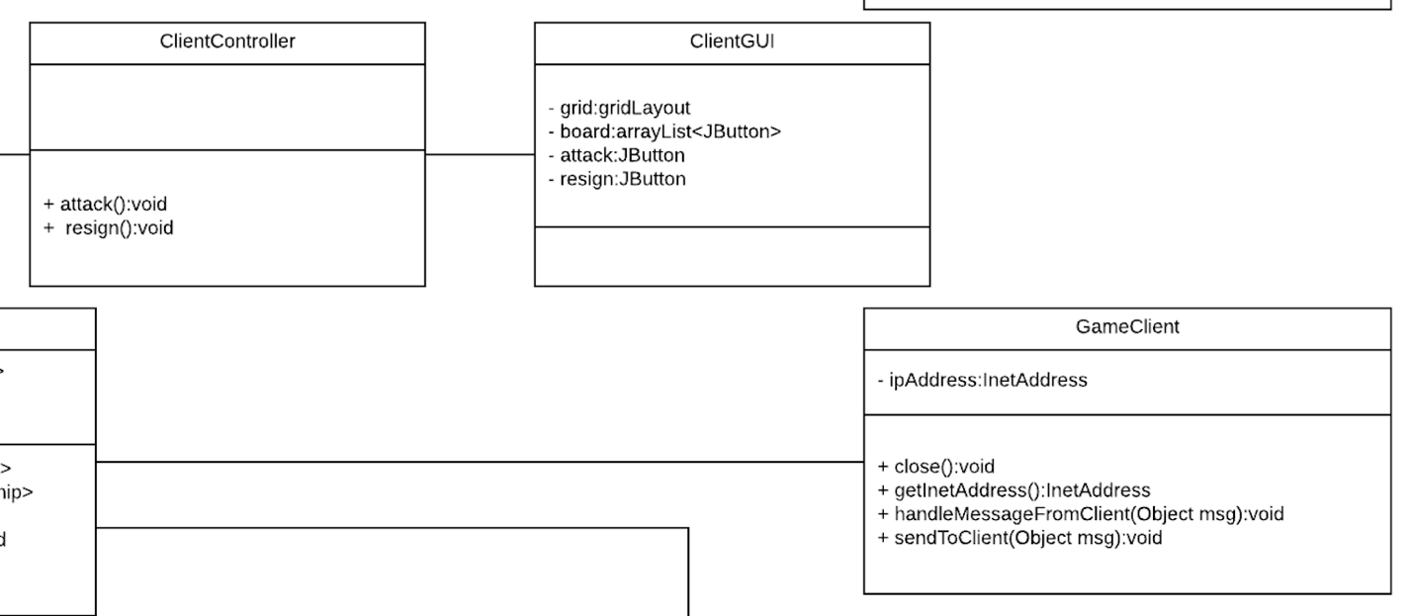

**Client Package**

**(OCSF Package image omitted because it came from an external JAR)**